VPC Challenges
Use Case: Setting up Transit Gateway and VPC Endpoints for a Multi-
VPC Architecture
Scenario:
A large organization is migrating its on-premises infrastructure to the AWS
cloud.
The organization's architecture involves multiple VPCs for different
departments and applications, each requiring secure communication with
centralized services and external resources.
The IT team needs to design and implement a scalable and efficient
network architecture to accommodate the organization's growth and ensure
robust connectivity between VPCs and external services.
Objectives:
• Design and deploy a scalable network architecture using AWS
Transit Gateway to simplify network connectivity between multiple
VPCs.
• Configure VPC endpoints to securely access AWS services without
internet gateways or NAT gateways, ensuring data privacy and
minimizing exposure to external threats.
Created two vpcs
• Created one Public subnet in vpc1
• Created one Private subnet in vpc2
• And created 2 route tables one for vpc1 and second
one for vpc2
• Created one internet gate way and attached to vpc
• Created two transit gateways
• Added transit gateways to route tables
• Created two ec2 instances one public and another
one is private
- Created two vpcs
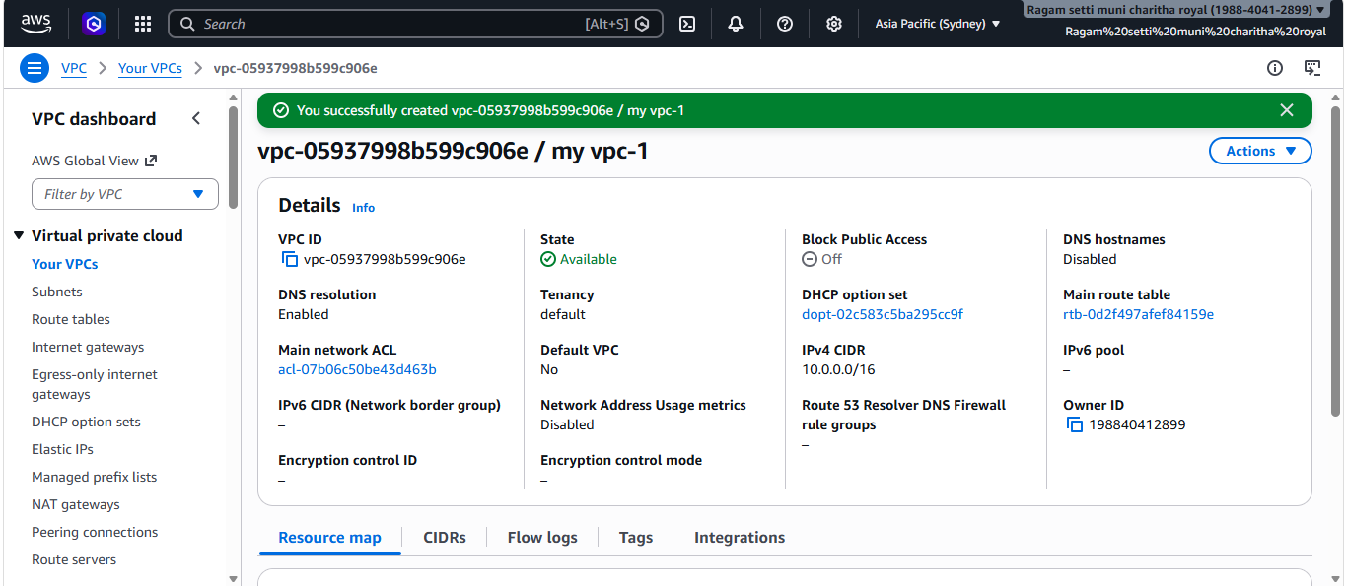
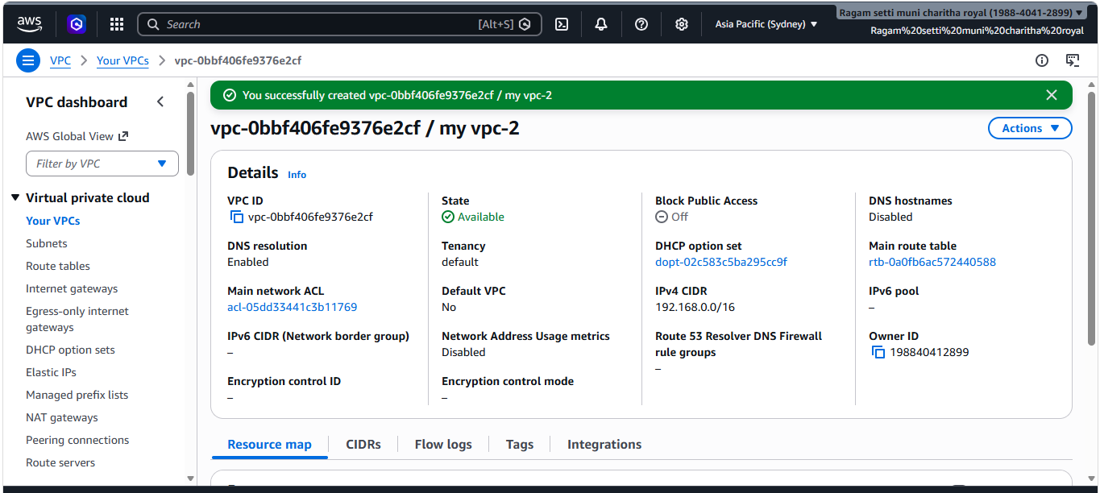
- Created one Public subnet in vpc1
- Created one Private subnet in vpc2
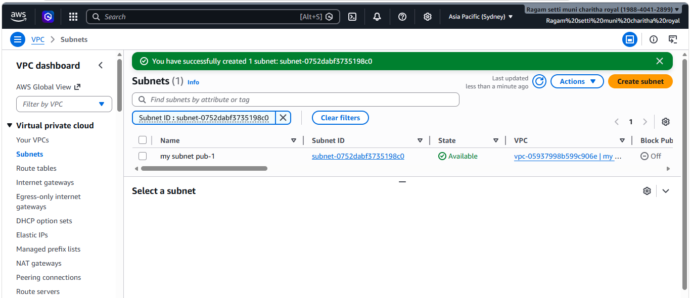
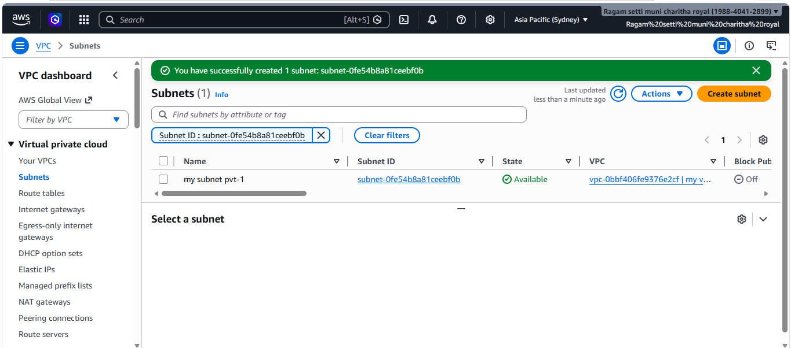
- And created 2 route tables one for vpc1 and second one for vpc2
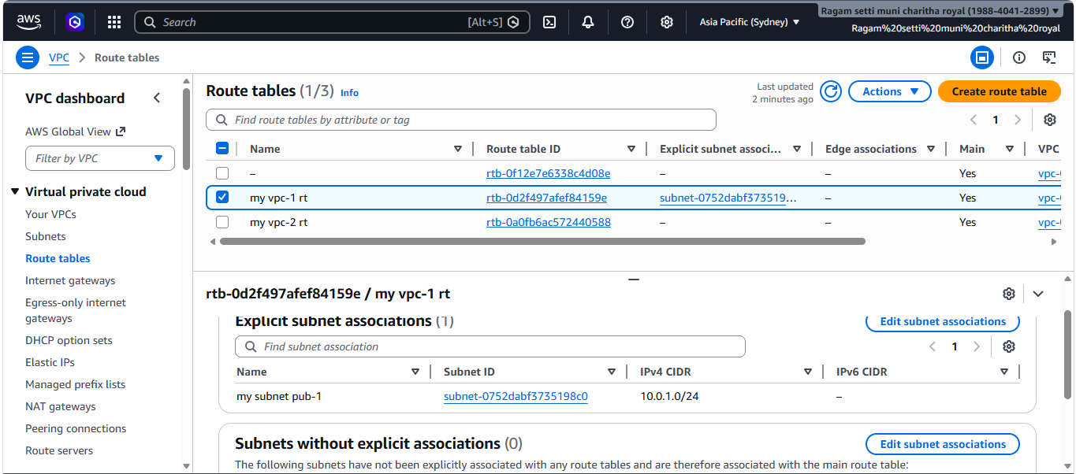
- Created one internet gate way and attached to vpc
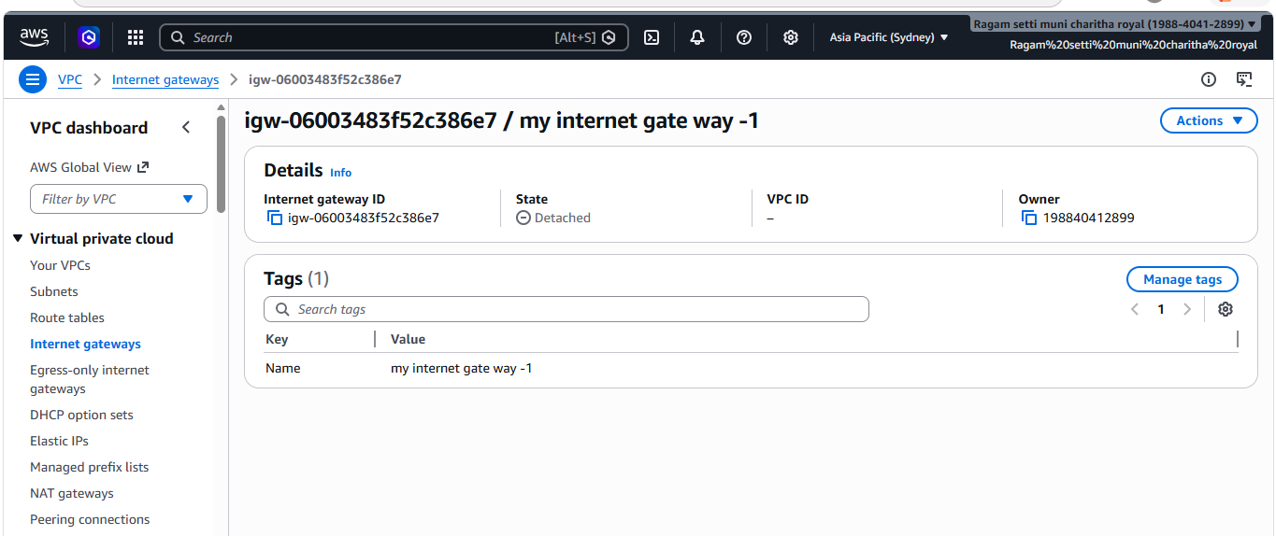
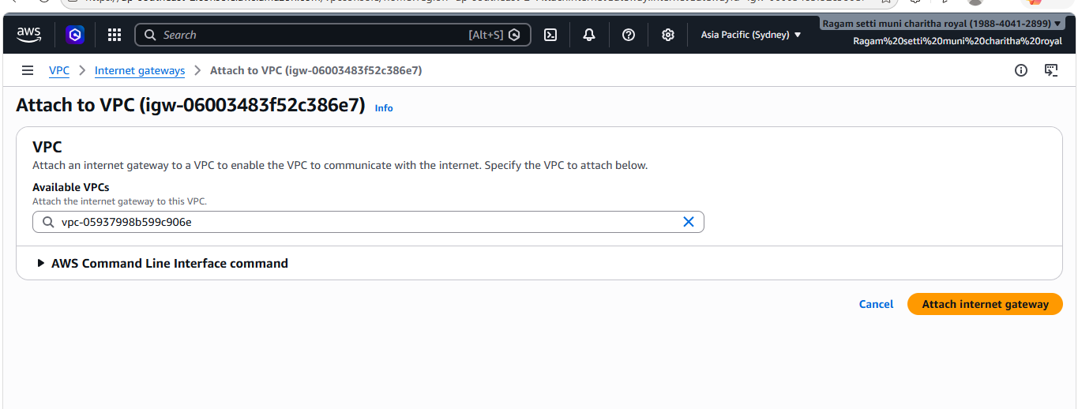
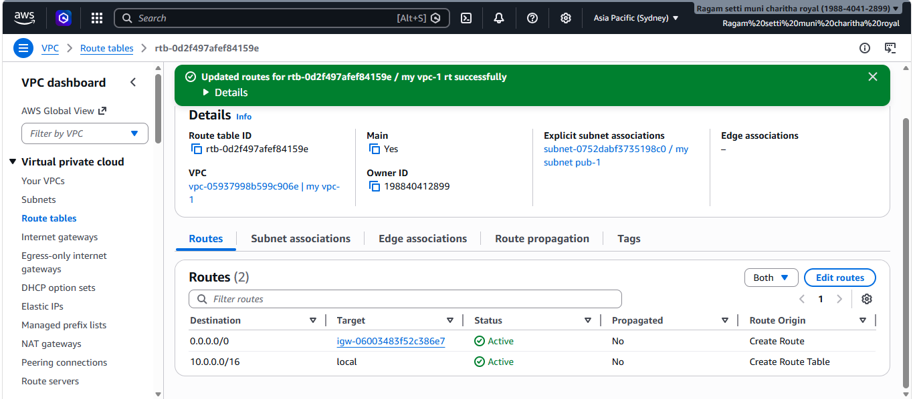
- Created two transit gateways
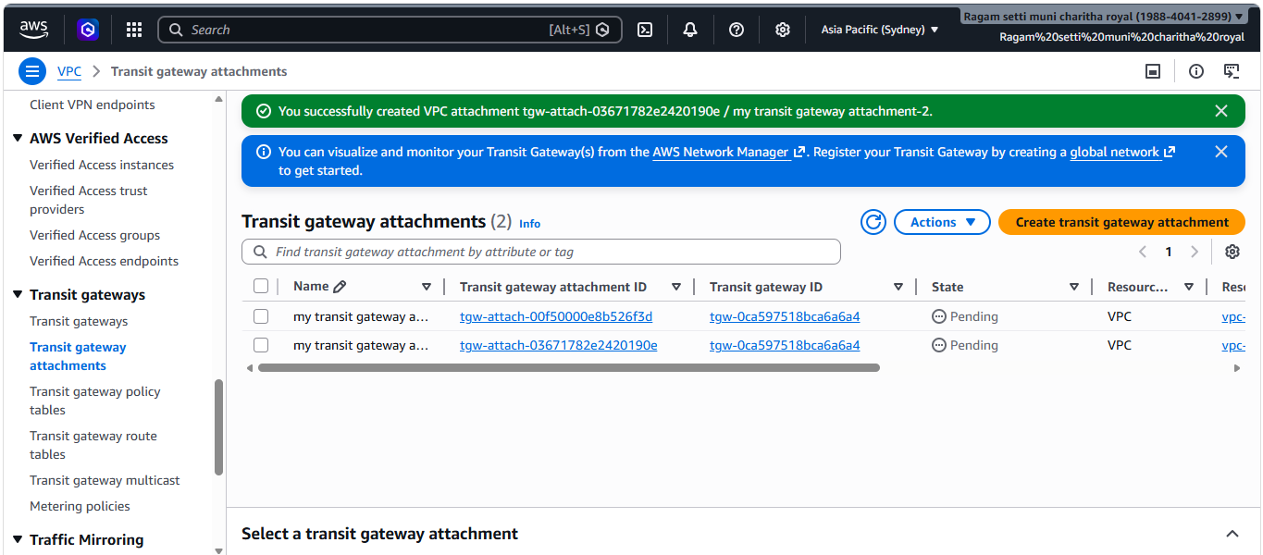
- Added transit gateways to route tables
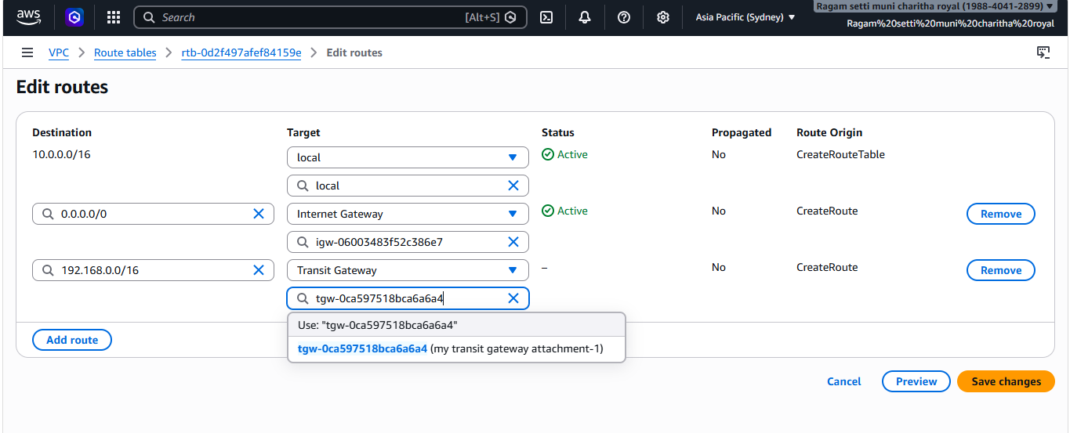
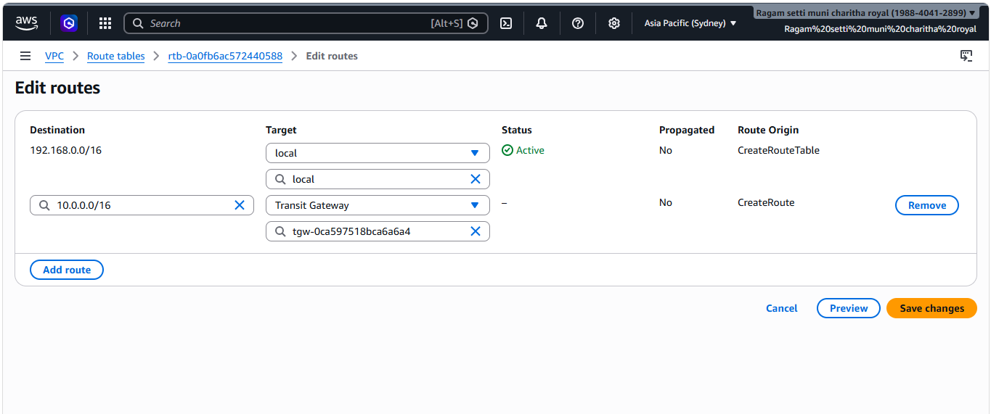
- Created two ec2 instances one public and another one is private
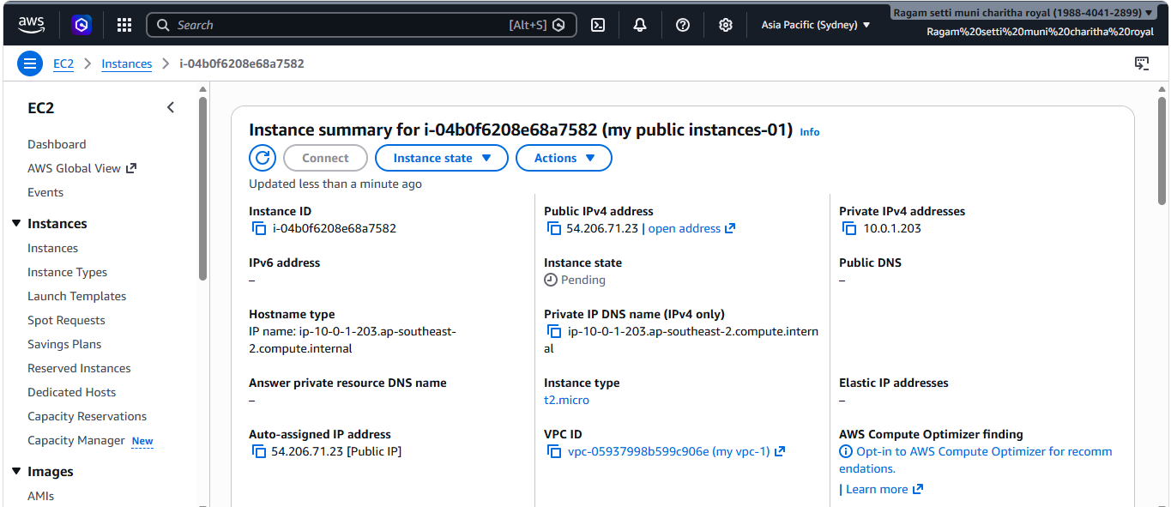
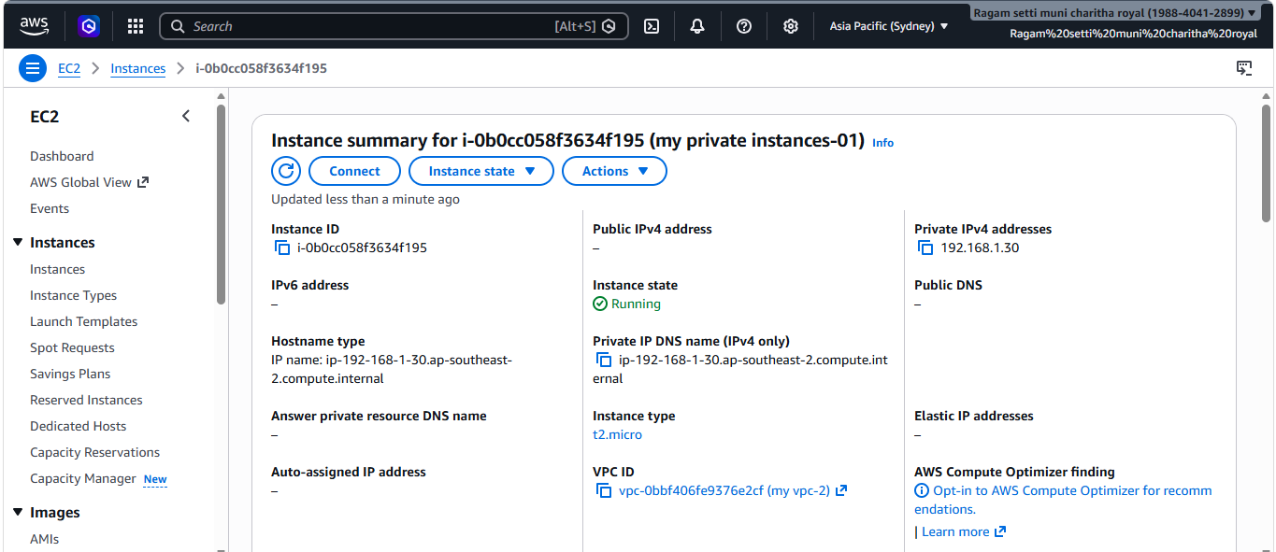
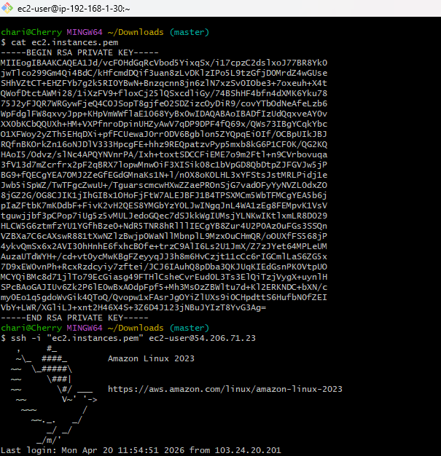
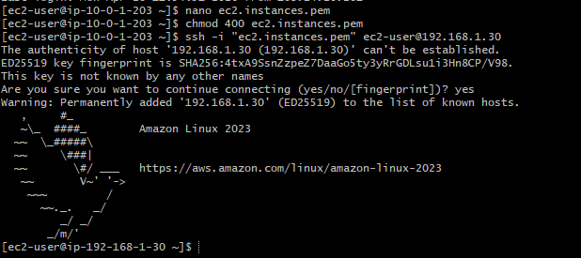
Created on endpoint with full access, s3 and vpc
- And created one policy and selected the policy i
created
- And changed the json policy allow to deny and
checked it worked
- Created on endpoint with full access, s3 and vpc
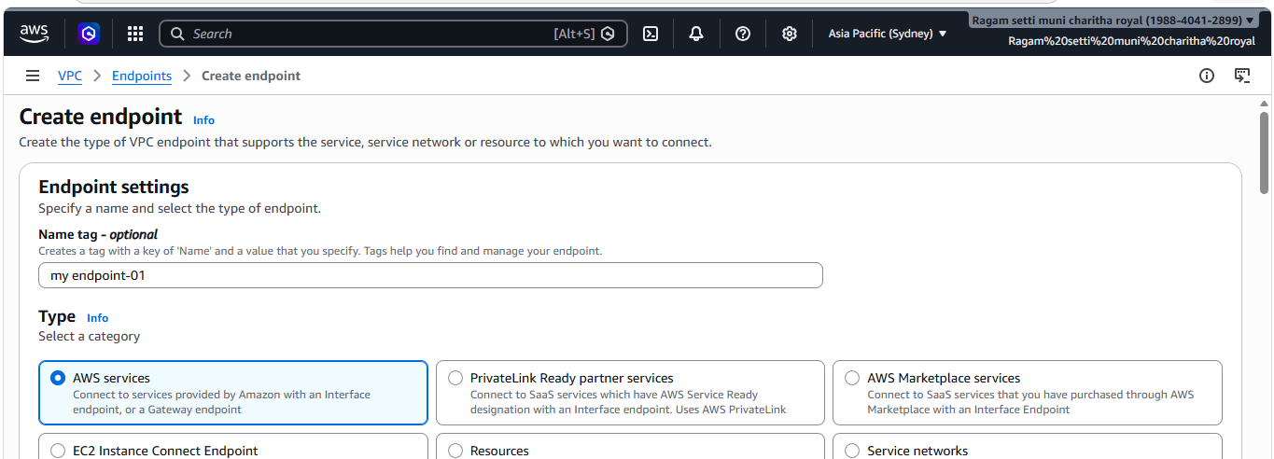
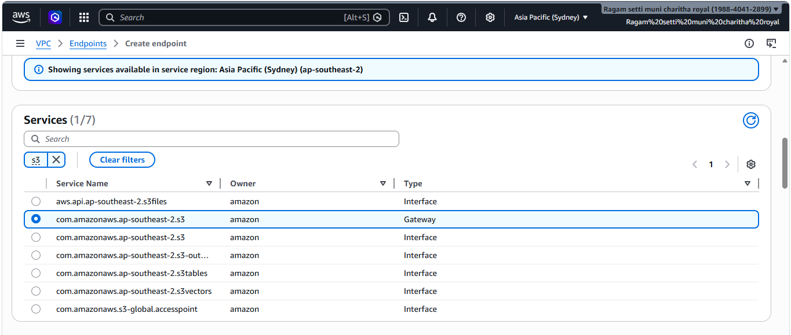
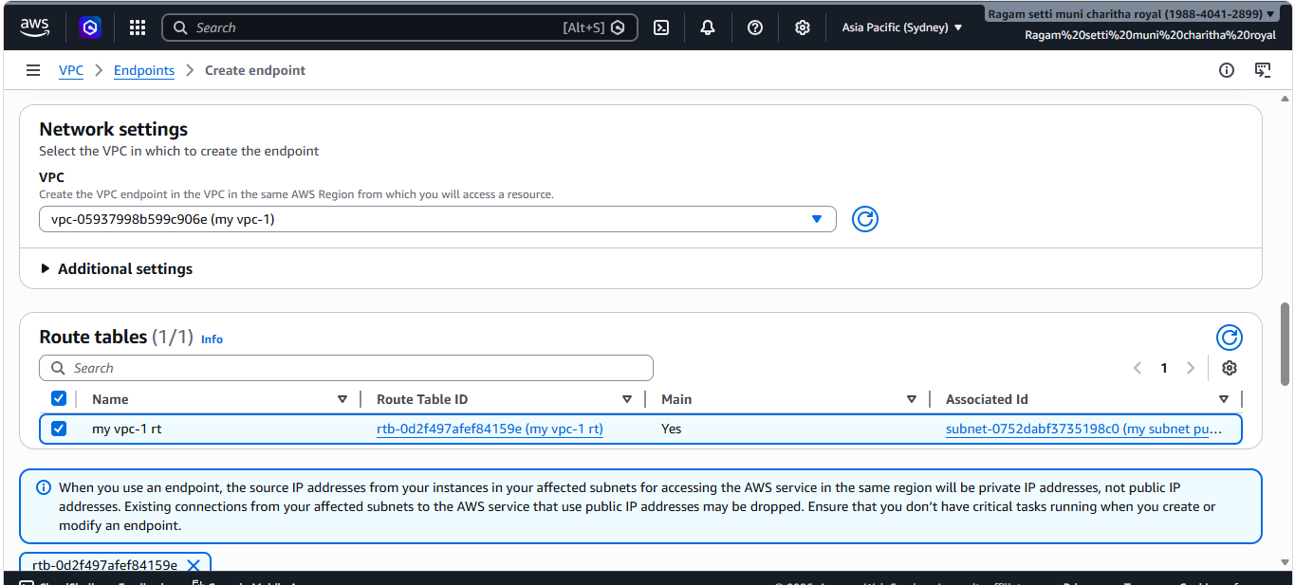
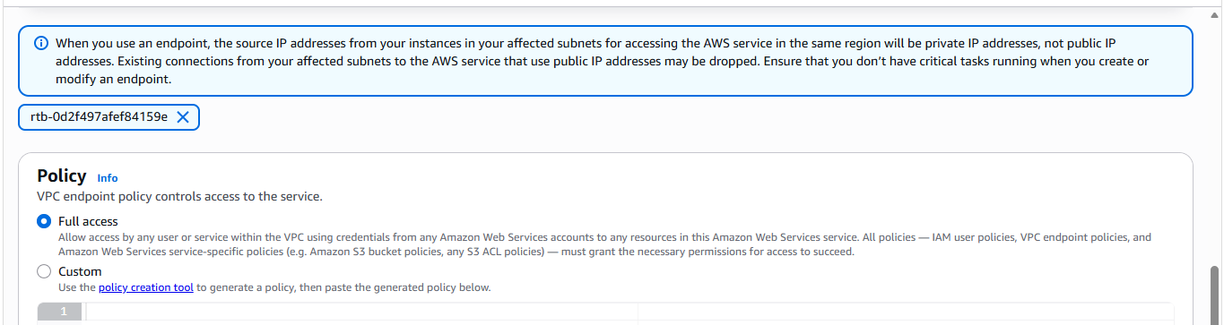
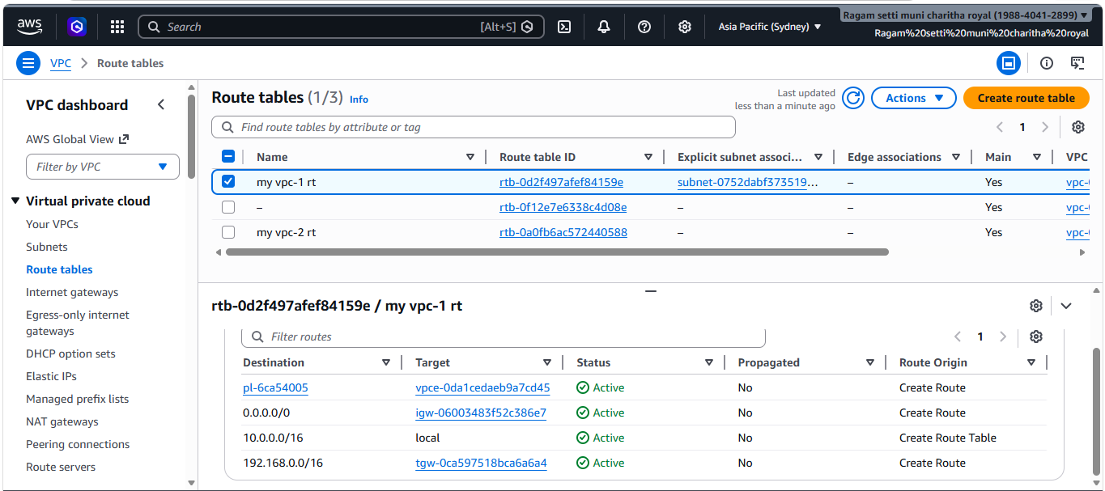
- And created one policy and selected the policy i created
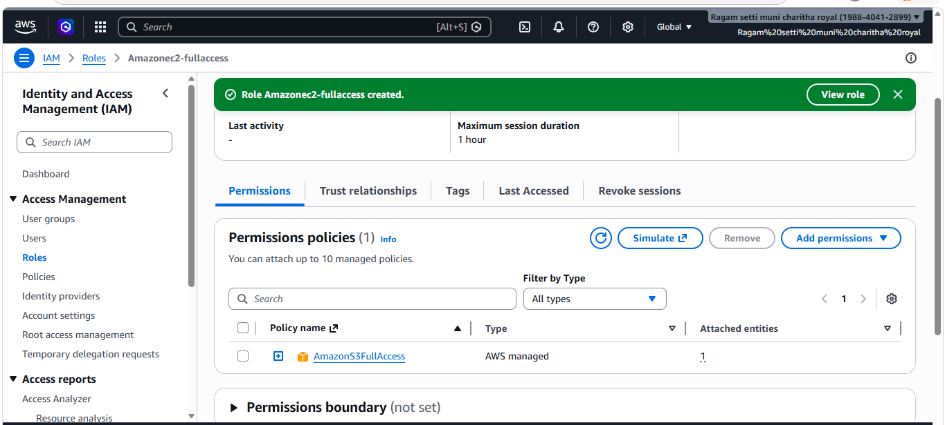
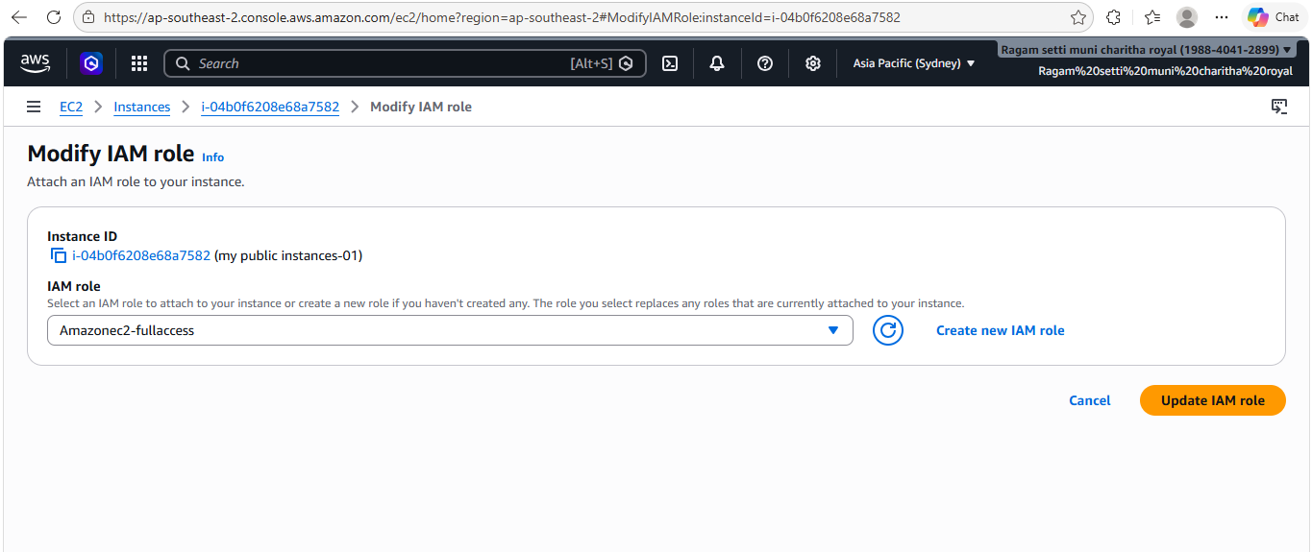
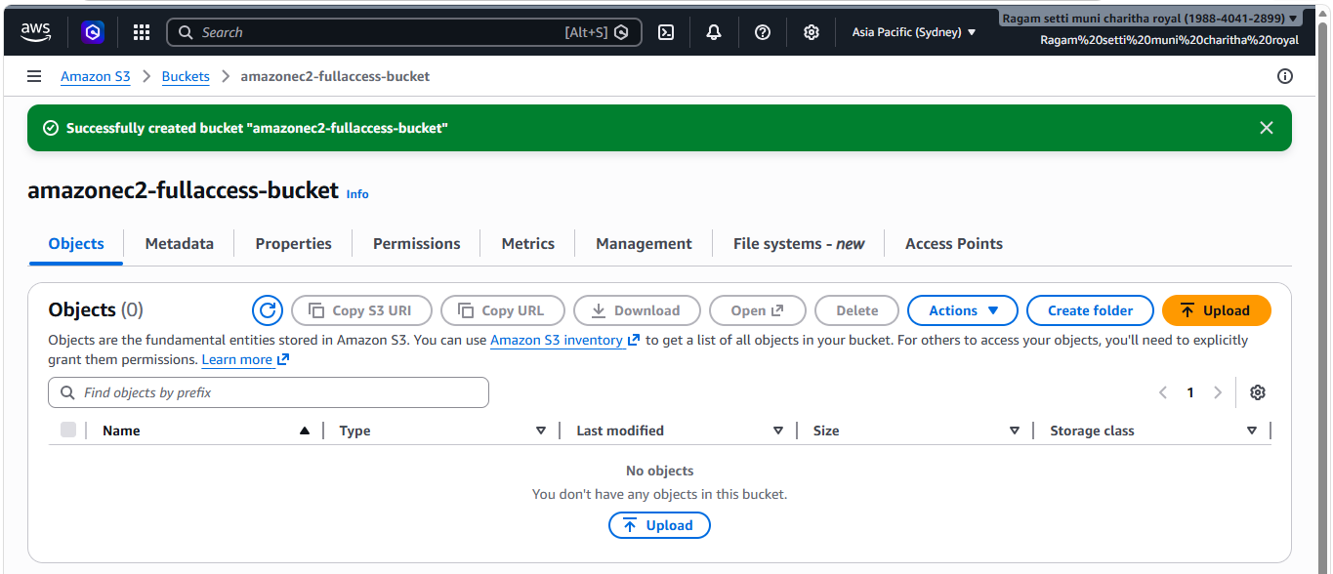
- And changed the json policy allow to deny and checked it worked
